# **PROJECT MILESTONE 0: EXPECTATIONS & BRAINSTORM FEATURES (Submitted by Felipe on 3/11/2021)**

**Group #13**: Wetblock  
  
**Group Members**:

* Andy Le - [hle29@uncc.edu](mailto:hle29@uncc.edu)
* Helen Nguyen - [hnguye89@uncc.edu](mailto:hnguye89@uncc.edu)
* Jon Ledbetter - [jledbe20@uncc.edu](mailto:jledbe20@uncc.edu)
* Barbara Saboe - [bsaboe@uncc.edu](mailto:bsaboe@uncc.edu)
* Diana Velazquez Ramos - [dvelazq1@uncc.edu](mailto:dvelazq1@uncc.edu)
* Felipe Orrego - [forrego@uncc.edu](mailto:forrego@uncc.edu)

[**Reports**](https://uncc.instructure.com/courses/147601/pages/status-report) **& Meetings:**

* Meeting times on Tuesdays and Thursdays:
  + Individual status reports by **every Monday 11:59 pm**
  + Team status reports by **every Monday 11:59 pm**
* *We will be reporting during our routine meetings*

[**Project Expectations**](https://uncc.instructure.com/courses/147601/pages/project)**:**

* We discussed the project expectations and how we are going to organize ourselves. We looked at potential examples to get a better understanding of what we are creating.

**Project Application:**

* We expect to know how to use Python Framework such as Flask or Django to develop a weblog with some features like managing users, managing articles. We also know how to apply the database knowledge on developing the back-end features on our project. We would like to know how to apply our knowledge about Git and Github to manage the version control during our work. We can spend time experiencing teamwork as a real team in a real project. We can apply to write the report weekly to know the status of our work.

**GITHUB Repository:** <https://github.com/hnguye89/ITSC3155Project.git>

**GROUP WORD FOLDER:** <https://drive.google.com/drive/u/2/folders/1RaNY3vxqmzy2AGoMElONhJrjd0neC3iP>

**What is the lowest grade your group will be satisfied with?**

* 95

**Our agreed time-management strategy will be to:**

* Our group chose option A. However, we agreed to keep track of our pace and work through any potential hangups.

**Describe how you will handle your team leadership.**

* As of this meeting, Felipe will be the facilitator for group meetings. John will help with documentation and assist with leadership as well.

**How do you plan to handle the situation if someone does not meet expectations? Has everyone agreed to this strategy?**

* We agreed to have open and regular communication. By regularly reporting our progress, we hope to catch any potential difficulties within ourselves first and foremost. Everyone in the group seems willing to help, and setting this expectation will help us to better manage expectations.

**List your software product features (at least 10):**

* Login for the user
* Register a new account for user/visitors
* Let the visitor can see the articles posted by the admin
* Let the audience can comment on their opinions
* Let the admin post a new article
* Admin edit the contents of the article,
* Admin can delete the article if they do not show it to their visitors.
* Pagination of the number of articles on one page to let the visitor follow the number of the article easily.
* Embed the links to Facebook, Twitter, Instagram
* Embed the calendar
* See the archived articles.

**Initial Product Backlog**

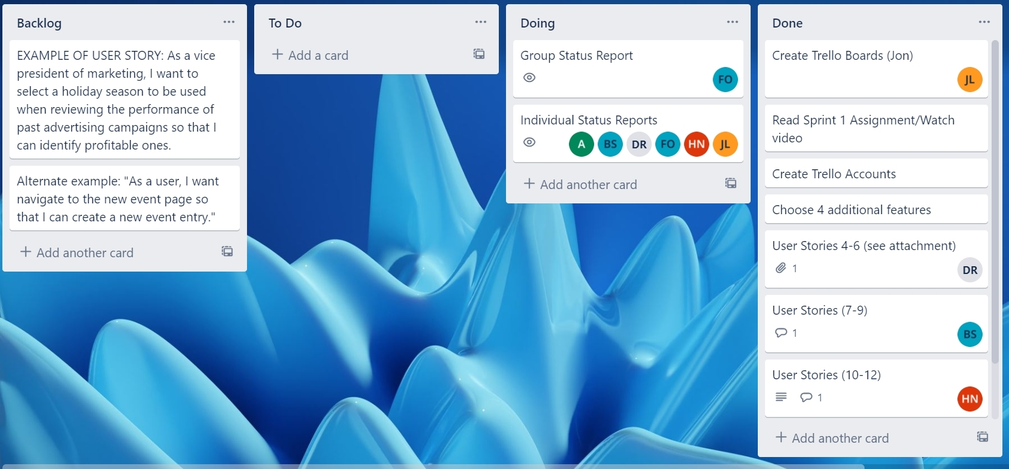

Trello Board Invite: <https://trello.com/invite/b/jxvUidik/4ad0b9a8ec8eb8384e94f916d7648d3b/wetblock-tracking>

Product Backlog #2:

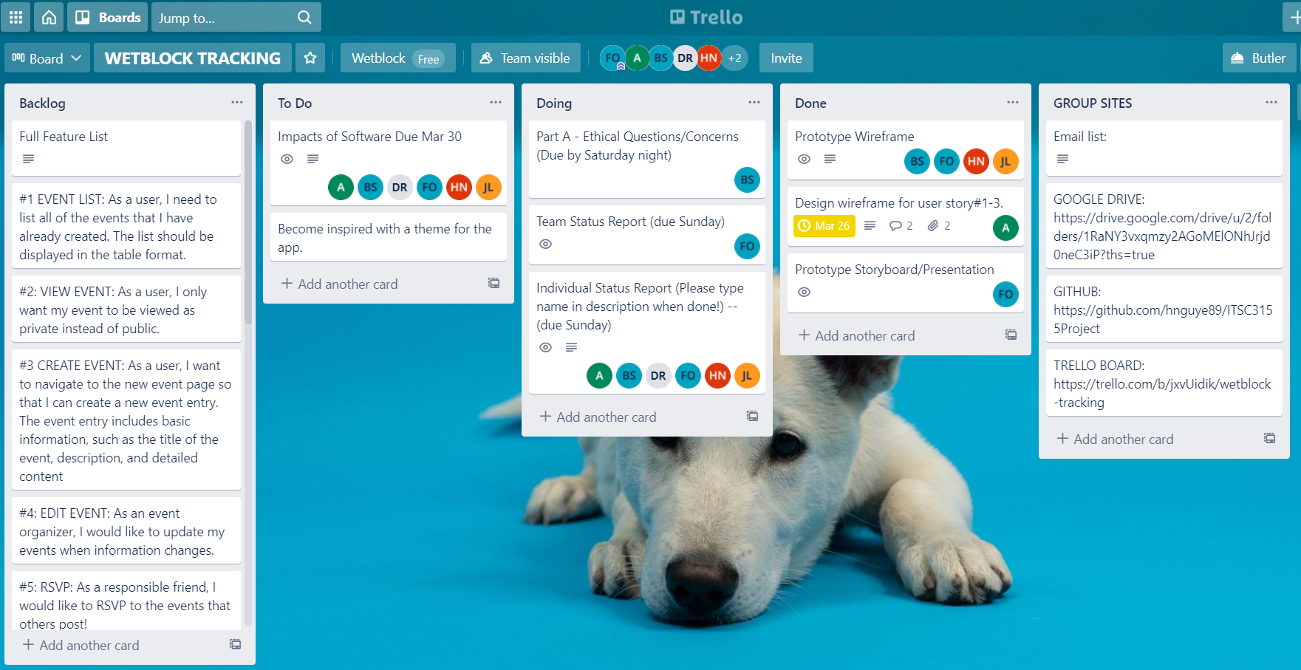

Product Backlog #3:

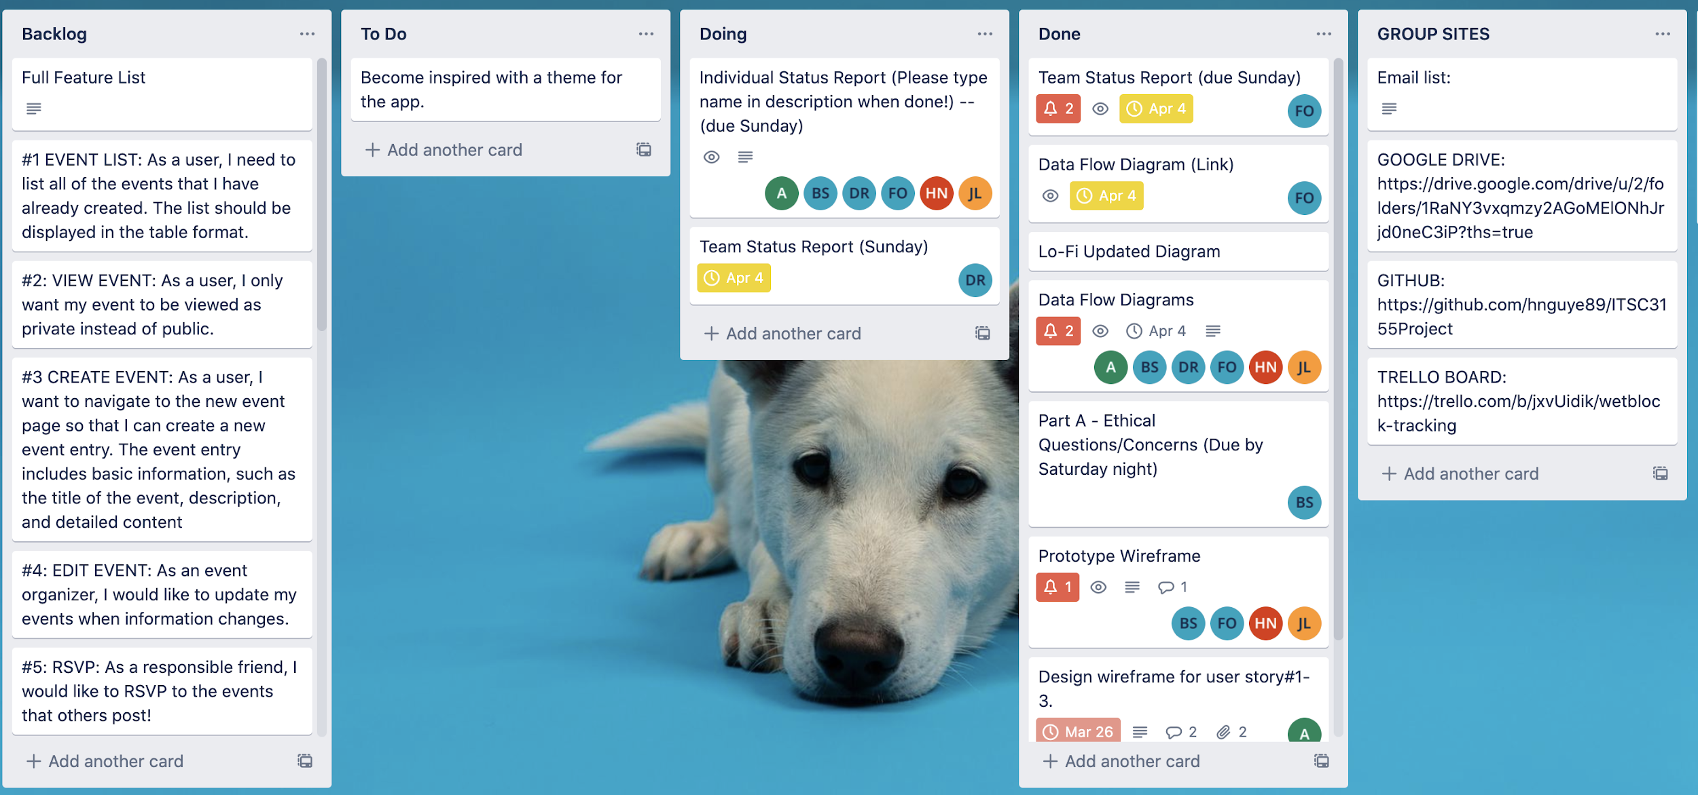

Product Backlog #4

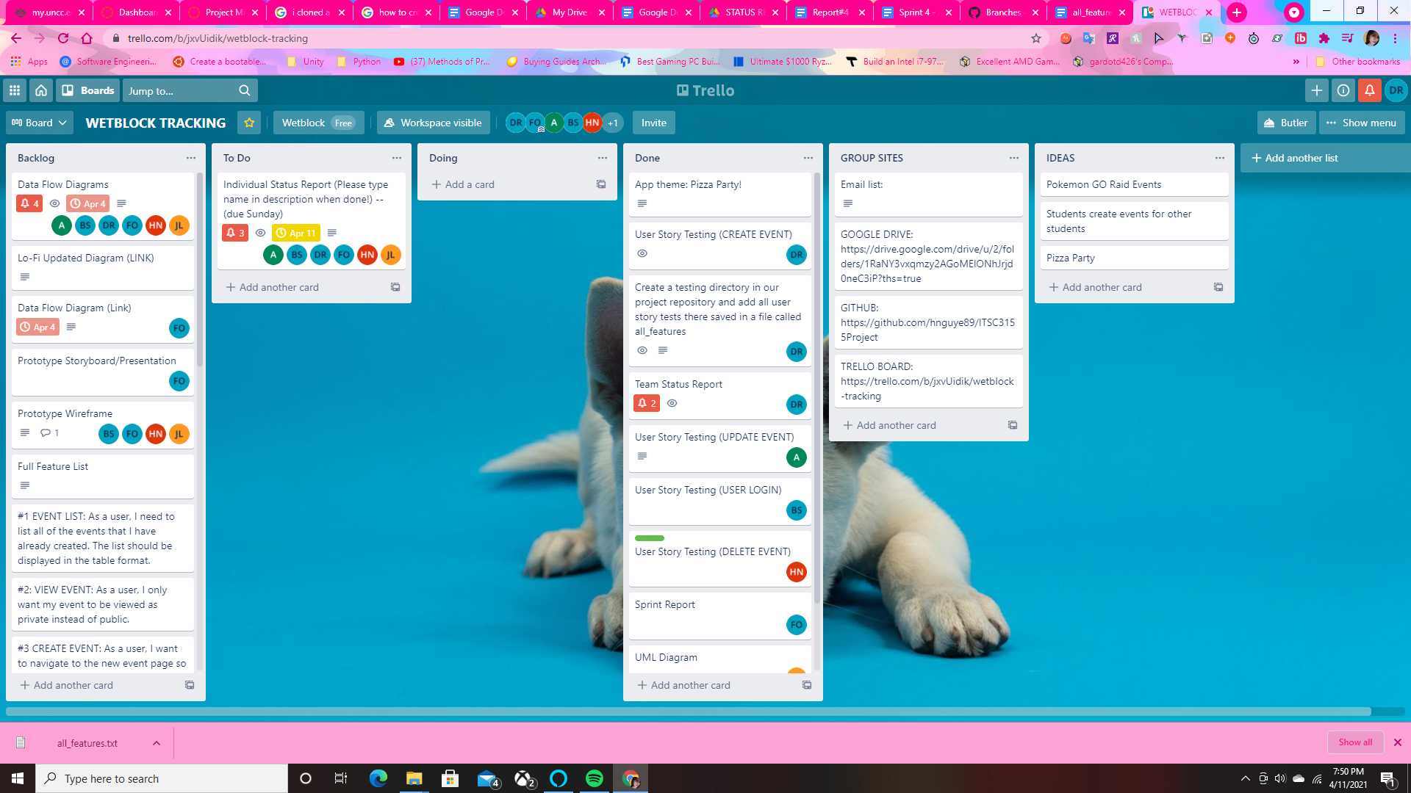

Product Backlog #6

